**A PERSONALIZED TRAVEL PLANNING AND TRACKING APP**

**Team Members:**

**MUNIYANDI .C : FB9CB547AB335E982F543CA6D7918E59**

**NANDHA GOPALAN.V :EFB4F9DE6721A758749439FC9DE1C00C**

**STALIN.AP : A49077C1F53DCDC973A4A9BA44CC027C**

**RAMAKRISHNAN.A : B317762782CA66C832B479C86D896061**

**EZHUMALAI.K : 1DAD6BE29931CD3AD0343A7BE7268416**

**MODULE 1:**

**DOWNLOAD ANDROID STUDIO**:

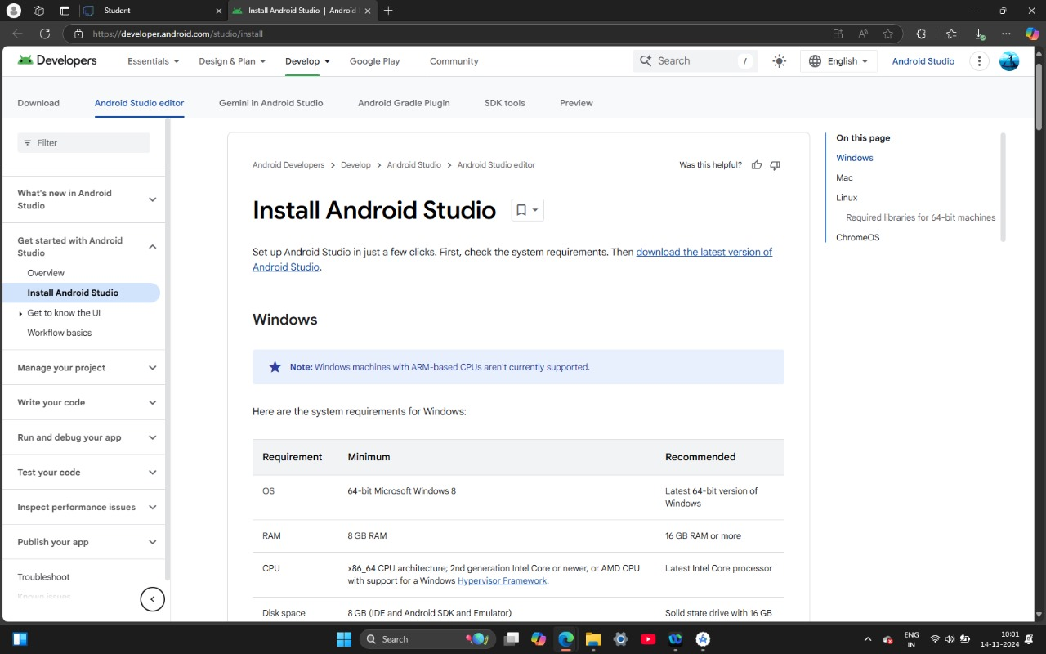

**INSTALLING ANDROID STUDIO** :

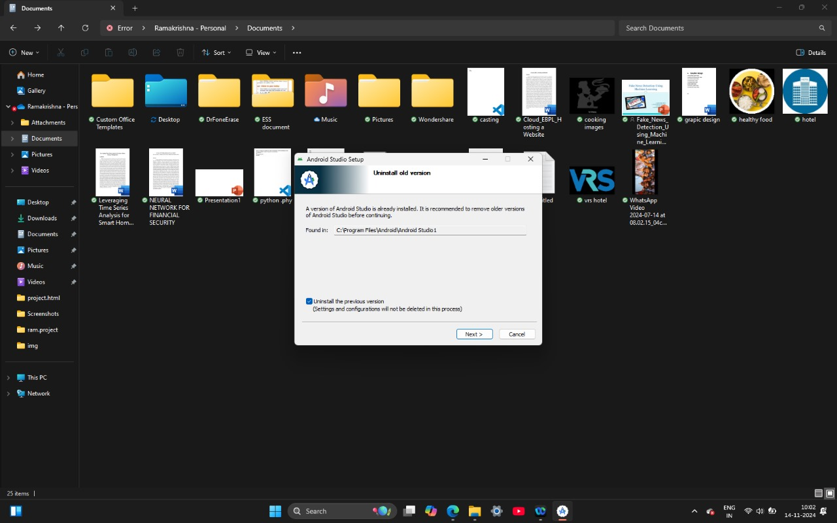

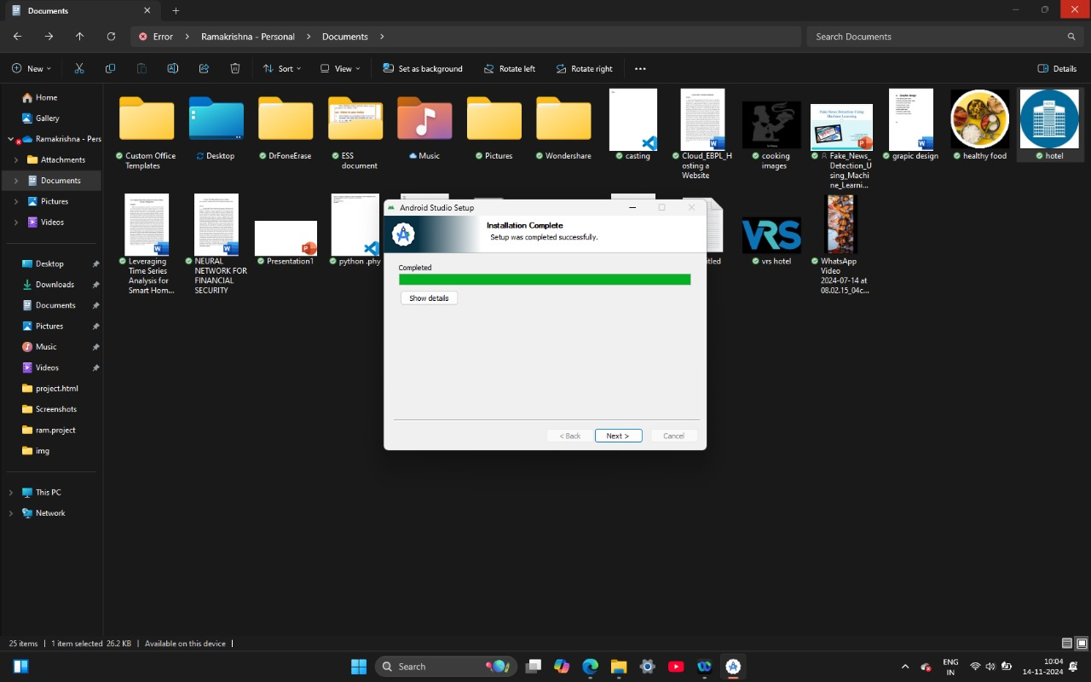

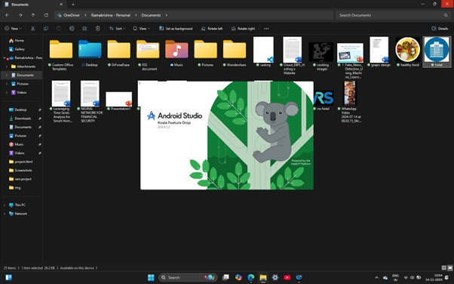

**CREATE NEW PROJECT :**

**Step :1**

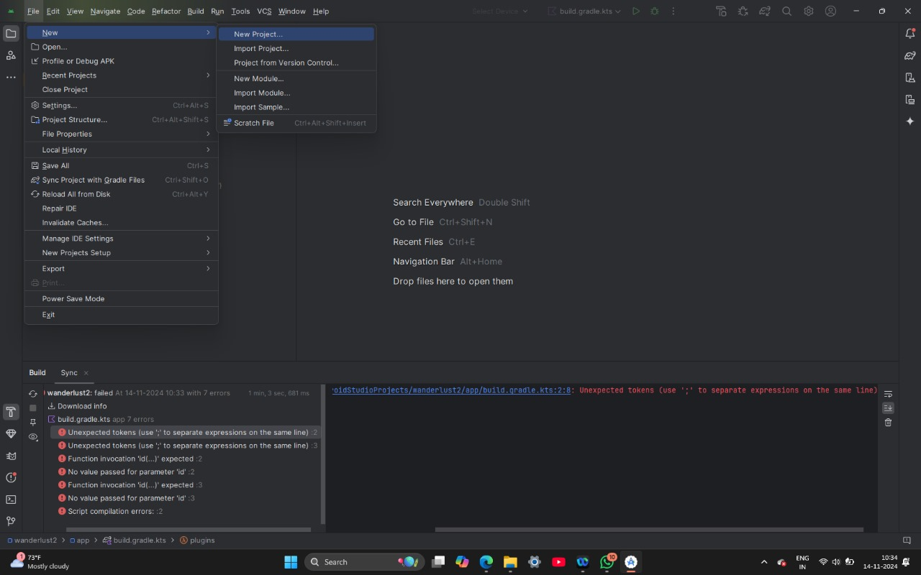

**Step :2**

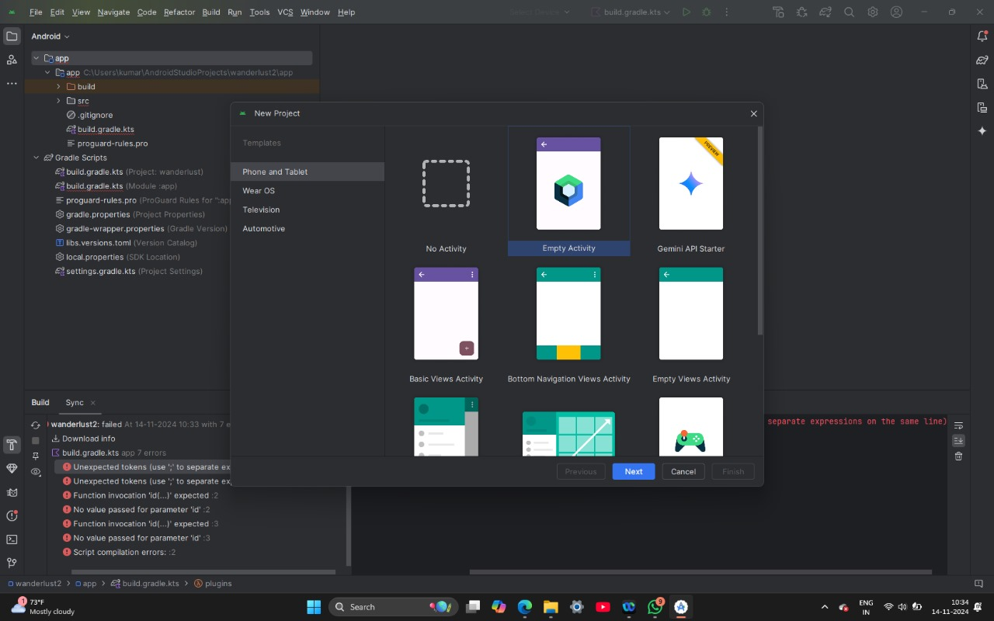

**Step :3**

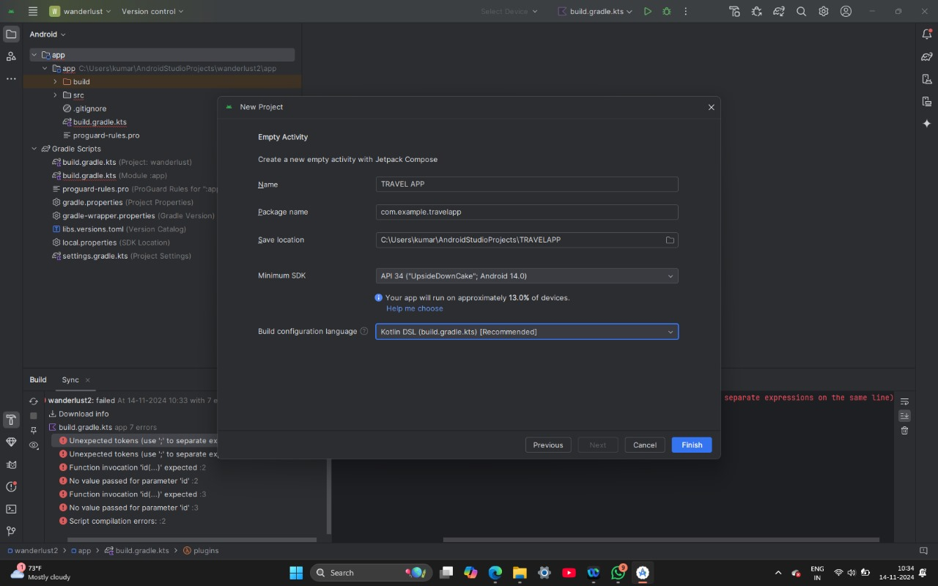

**Step :4**

